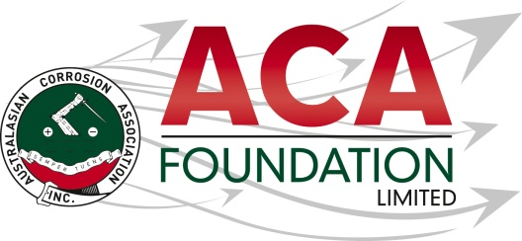[](http://www.phoenixsolutions.co.nz/)

**Infrastructure & Asset Specialists**

**Phoenix Solutions**

**Professional ACA Training Course or Conference Attendance Scholarship**

**About the Scholarship**

The purpose of this Scholarship is to support an individual who is involved in the construction or asset management industry, Engineering professional or student for an ACA Training course or attendance at the ACA annual conference. This award is open to applicants from all areas of the construction and/or corrosion related industries including, but not limited to asset owners/managers, materials suppliers, consultants, contractors, students, scientists and engineers.

**About the ACA Foundation Limited**

ACA Foundation Limited was created for the advancement of corrosion education for the benefit of the broader community. The Foundation’s range of activities focus on Scholarships and development of corrosion related educational resources.

The ACA Foundation Limited is financially supported by The Australasian Corrosion Association Inc, its various Branches and members.

**About Phoenix Solutions**

Phoenix Solutions are a New Zealand Based Consulting company who specialise in the durability of large infrastructure and assets. Their primary areas of expertise are Cathodic Protection, corrosion mitigation, inspection and remediation of existing structures. They provide professional services to solve corrosion and durability related issues to clients across New Zealand, Australia and the Pacific Islands.

**Detailed Description of the Scholarship**

Number of Scholarships available 1

Value of each Scholarship NZ$2,000 contribution to ACA conference or training course

Scholarship application open 20 June 2024

Scholarship application close 15 August 2024

Scholarship announced 16 September 2024

The Scholarship is in the form of a NZ$2,000 contribution to the ACA annual conference or an ACA training course.

It is expected the scholarship recipient will provide a brief report of their conference experience including an outline the following:

* Introduction of individual
* What has been the key benefit to them as a result of attending the conference?
* What will they take away from the conference for future?
* Provide thanks to their sponsors – Phoenix Solutions and ACAF

**Guidelines for Eligibility for the UCC Professional Scholarship**

1. Applicant is a citizen or permanent resident of New Zealand
2. If requested, applicants must provide a copy of their birth certificates or proof of residency/citizenship.
3. An application form must be completed and submitted to the ACA Foundation Limited by the deadline, including the following details.

* Name & Contact Details
* Company/Institution Details
* Academic, conference/courses and work histories
* 250 word outline in support of the application
* Letter of support from company/institution
* 2 referees

1. Applications for an ACA Foundation Limited Scholarship are made directly to the ACA Foundation.
2. Scholarships are only awarded in response to applications. If no applications have been received, that the judging panel believe warrant a Scholarship, then no Scholarship will be awarded.
3. The applicant must demonstrate that their employer or educational institution will support their application and participation in the Scholarship.
4. The ACA Foundation Limited Scholarship judging panel will be determined by the ACA Foundation Limited Board
5. The judges reserve the right to request a brief presentation via teleconference with short listed applicants.
6. The ACA Foundation Limited Judging Panel’s decision is final.
7. The Scholarship’s shall be judged upon the following criteria:

* Ability to present a clear and concise case
* Referee’s comments
* ACA Foundation’s focus on access, equity, and participation

1. Each Scholarship recipient will be contacted by the ACA Foundation and their names/images will appear in ACA and ACA Foundation Limited collateral.